Final Report
1. Executive Summary
This report presents the final Quality Assurance (QA) testing activities conducted as part of the Software Testing – Quality Assurance capstone project. The objective of this project was to plan, design, execute, automate, and analyze a comprehensive set of functional and non-functional tests for a simulated retail platform, in alignment with industry’s best practices and assignment requirements.
The system under test represents a retail e-commerce solution named “Loyalty+ Store”, which includes a web-based user interface for customer interactions and a RESTful backend API for business logic and data handling. To achieve realistic testing conditions, two real-world practice platforms were used: Sauce Demo (Swag Labs) for web UI testing and Dummy JSON API for backend API testing. These systems allowed the execution of end-to-end testing scenarios without the use of real personal or payment data.
The QA process followed a structured testing lifecycle, starting with detailed test planning and risk identification, followed by manual testing, automated API testing, performance testing, and UI automation. A formal Test Plan was prepared to define the testing scope, assumptions, environments, risks, and entry/exit criteria. Based on this plan, manual test cases were designed and executed to validate core functionalities such as authentication, product browsing, cart management, and checkout workflows. Defects identified during execution were documented with clear reproduction steps, severity, and priority to simulate a real defect tracking process.
API testing was a major focus of this project. A comprehensive Postman collection was created to cover authentication, product management, cart operations, and negative test scenarios. Automated assertions were implemented to validate status codes, response structures, and critical fields. The collection was executed using Newman to ensure repeatability and to generate execution reports suitable for continuous integration environments.
To assess system performance, API performance testing was conducted using k6. Multiple load profiles, including smoke and load tests, were executed against selected API endpoints. Key performance indicators (KPIs) such as response time, throughput, and error rate were collected and analyzed. The results provided insights into system behavior underload and highlighted potential performance bottlenecks, along with practical improvement recommendations.
In addition to API testing, UI automation was implemented using a structured and maintainable approach. Critical user journeys were automated to validate the stability of the web application and to demonstrate the value of regression testing in a CI-ready environment. All testing artifacts, scripts, and reports were version-controlled and published to a GitHub repository, ensuring transparency, traceability, and reproducibility.
Overall, this project demonstrates a complete and professional QA testing workflow, combining manual and automated techniques to ensure software quality. The outcomes reflect the application of theoretical knowledge to a practical system and showcase essential QA skills required in real-world software development environments.
2. System Under Test and Assumptions
2.1 System Under Test (SUT)
The system under test for this project represents a simulated retail e-commerce platform named “Loyalty+ Store”, designed to reflect a real-world online shopping experience. The system consists of two main components: a web-based user interface (UI) and a RESTful backend API. Each component was tested independently and as part of end-to-end workflows to ensure functional correctness, reliability, and performance.
Web User Interface (UI)
The web UI testing was conducted using Sauce Demo (Swag Labs), a publicly available demo e-commerce application. This platform simulates a customer-facing online store and provides core retail functionalities, including:
- User authentication (login and logout)
- Product listing and product details
- Shopping cart management
- Checkout and order completion
- Order history and navigation flows
Sauce Demo was selected because it provides stable, realistic user journeys suitable for both manual and automated testing, while allowing the execution of critical business scenarios without the use of real customer or payment data.
Backend API
The backend testing targeted the Dummy JSON REST API, which simulates retail-related backend services. This API was used to validate server-side logic and data handling through RESTful endpoints over HTTP. The API testing scope included:
- Authentication and authorization (JWT-based login)
- Product management endpoints (list, search, retrieve, create, update, delete)
- Cart operations (create cart, retrieve carts, calculate totals)
- User-related endpoints
- Negative and boundary test scenarios
The Dummy JSON API was selected as it provides comprehensive documentation, realistic request/response structures, and supports automated testing and performance testing without persisting real data.

2.2 Test Environment
All testing activities were conducted in a controlled test environment using publicly available demo systems. The following tools and environments were used:
- Web Browser: Microsoft Edge (latest stable version)
- API Testing Tool: Postman with environment variables
- Performance Testing Tool: k6
- UI Automation Tool: Selenium WebDriver
- Version Control: Git and GitHub
- Operating System: Windows
These tools and environments were selected to closely resemble industry-standard QA workflows and to ensure test repeatability.

2.3 Assumptions
The following assumptions were made during the testing process to ensure consistency and compliance with the assignment rules:
- All test data used during testing (usernames, passwords, product data) is non-sensitive and intended solely for testing purposes.
- No real personal, financial, or payment information is used at any stage of testing.
- The DummyJSON API simulates write operations (POST, PUT, DELETE) and may not persist changes; therefore, tests validate response behavior rather than long-term data storage.
- Performance testing is conducted within reasonable load limits to avoid stressing or disrupting the public demo services.
- The availability and behavior of the demo systems may change over time; any unexpected outages or inconsistencies are treated as environmental limitations rather than functional defects.
- Security testing activities such as vulnerability scanning, penetration testing, or brute-force attacks are explicitly excluded from the testing scope.

2.4 Scope Alignment
The selected systems and assumptions align with the objectives of this project by enabling comprehensive functional and non-functional testing while respecting ethical testing practices and platform usage rules. This approach ensures that the testing results are realistic, repeatable, and suitable for academic and professional evaluation.
3. Test Strategy and Scope
3.1 Test Strategy
The testing strategy for this project was designed to ensure comprehensive validation of both functional and non-functional aspects of the Loyalty+ Store system. The strategy follows a structured Quality Assurance approach that combines manual testing, automation testing, API testing, and performance testing to achieve reliable coverage of critical business functionalities.
The strategy focuses on validating the system from the user interface level down to the backend API layer. This layered approach ensures that defects can be detected early, system behavior can be verified under normal and load conditions, and core user journeys can be validated end-to-end.
Testing activities were executed in the following order:
- Test planning and scope definition.
- Manual testing of core Web UI functionalities.
- Automated API testing using Postman.
- API performance testing using k6.
- UI automation testing using Selenium WebDriver.
- Defect reporting, analysis, and final documentation.
This strategy aligns with industry best practices by balancing exploratory manual testing with repeatable and maintainable automated tests.

3.2 Testing Levels and Types
The following testing types were included as part of the overall test strategy:
Testing Type | Description
Manual Testing | Validation of core Web UI functionalities such as login, product browsing, cart management, and checkout flows.
API Testing | Verification of REST API endpoints including authentication, product retrieval, cart operations, and negative scenarios.
Automation Testing | Execution of automated UI test cases using Selenium to validate critical user journeys and support regression testing.
Performance Testing | Evaluation of API performance under smoke and load test conditions using k6.

This combination of testing types ensures both functional correctness and system reliability under load.
3.3 Test Scope
In-Scope Testing
The following activities were included within the scope of testing for this project:
- Manual testing of the SauceDemo Web UI.
- API testing using Postman for authentication, products, and cart-related endpoints.
- Performance testing using k6, including smoke tests and load tests.
- UI automation testing using Selenium WebDriver.
- Defect identification, documentation, and classification.
Out-of-Scope Testing
The following activities were explicitly excluded from the testing scope:
- Security testing (e.g., penetration testing, vulnerability scanning).
- Cross-browser testing.
- Testing on live production environments.

3.4 Testing Tools
The tools used to support the testing strategy are listed below:
Tool | Purpose
Postman | API testing and automated API assertions
k6 | API performance testing (smoke and load tests)
Selenium WebDriver | UI automation testing
Microsoft Edge | Web UI manual testing
Word & Excel | Test documentation and defect tracking
Git & GitHub | Version control and collaboration

3.5 Testing Approach
API Performance Testing (k6)
Performance testing was conducted to evaluate the system’s ability to handle load and respond reliably under stress. Two main test profiles were executed:
- Smoke Testing: To validate basic API availability and correct responses for endpoints such as products, carts, and users.
- Load Testing: To measure system behavior under increased traffic, using 20 virtual users for a duration of 30 seconds.
Key performance metrics such as response time and HTTP status codes were monitored and analyzed.
UI Testing and Automation (Selenium)
UI testing focused on validating critical user scenarios, including:
- Login with valid credentials.
- Adding and removing products from the shopping cart.
- Completing the checkout process.
- Verifying product sorting functionality.
- Validating cart behavior.
Automated UI tests were implemented using Selenium WebDriver to improve test repeatability and support regression testing.
API Testing (Postman)
API testing was executed to validate request-response behavior for both positive and negative scenarios, including:
- Login with valid and invalid credentials.
- Retrieving products and carts.
- Adding and updating product data.

3.6 Entry and Exit Criteria
Entry Criteria
- Approved test plan.
- Test environment fully prepared.
- Required test data available (user credentials, product data).
Exit Criteria
- All planned test cases executed.
- Critical defects identified and documented.
- Final test reports completed.

3.7 Metrics and Reporting
Testing progress and quality were evaluated using the following metrics:
- API response time and status codes.
- Performance behavior under load.
- Number of executed test cases.
- Test results (Pass/Fail).
- Defects identified and categorized by severity.
These metrics provided visibility into system quality and supported informed testing conclusions.
4. Manual Testing: Scenarios, Coverage, and Execution Summary
4.1 Manual Testing Overview
Manual testing was conducted to validate the core functional requirements of the Loyalty+ Store web application. The primary objective of manual testing was to ensure that critical user workflows operate correctly from an end-user perspective before relying on automation. This phase focused on identifying functional defects, usability issues, and logical inconsistencies in the system.
The Sauce Demo (Swag Labs) web application was used as the target system for manual testing. Testing activities covered the most important business scenarios, including authentication, product interaction, cart management, and checkout functionality.
4.2 Test Scenarios Coverage
Manual test scenarios were designed to cover both positive (happy path) and negative scenarios to ensure robust validation of system behavior. The following table summarizes the main areas covered during manual testing:
Functional Area | Covered Scenarios
Authentication | Login with valid credentials, login with invalid credentials
Product Management | View product list, verify product details, product sorting
Cart Functionality | Add product to cart, remove product from cart, view cart
Checkout Process | Enter checkout information, complete purchase
Navigation & UI | Page navigation, button interactions, error messages

These scenarios ensured sufficient coverage of the most critical features that directly impact user experience.
4.3 Test Case Execution Summary
A total of 20 manual test cases were executed during the testing phase. Each test case was documented with clear steps, expected results, and actual outcomes. Test execution results were recorded to assess system stability and functional correctness.
Execution Summary
Test Status | Number of Test Cases
Passed | 12
Failed | 8
Blocked | 0

The majority of the test cases (12 out of 20) passed successfully, indicating that the core functionalities of the application are stable. The 8 failed test cases were primarily related to cart behavior and product validation, and they were documented as defects.
4.4 Defect Identification During Manual Testing
During manual test execution, 8 defects were identified. These defects were documented with clear reproduction steps, screenshots, and severity classification to simulate a real-world defect reporting process.
Defects identified during this phase included:
- Functional issues related to cart behavior.
- Validation-related issues during negative test scenarios.
- UI inconsistencies affecting usability.
Each defect was assigned a severity level (High, Medium, or Low) based on its impact on system functionality and user experience.
4.5 Manual Testing Effectiveness
Manual testing proved effective in identifying issues that are difficult to detect through automation alone, particularly in terms of usability and UI behavior. The results of this phase provided a strong foundation for subsequent automation testing by ensuring that critical user paths were well understood and validated.
Additionally, insights gained from manual testing were used to:
- Improve automated test design.
- Identify regression-prone areas.
- Validate test data and assumptions.
4.6 Summary
The manual testing phase successfully validated the core functionalities of the Loyalty+ Store web application. The combination of positive and negative scenarios ensured adequate functional coverage, while defect documentation supported quality tracking and analysis. Overall, manual testing contributed significantly to improving system reliability and readiness for automation and performance testing phases.

5. Defects: Top Issues, Severity Distribution, and Examples
5.1 Top Issues Identified
Bug ID | Category | Description
BR001 | Name | The "Last Name" field does not accept keyboard input or data entry.
BR002 | Product Price | "Sauce Labs Fleece Jacket" displays a mathematical error instead of a price.
BR003 | Product Sorting | Sorting products (Price, A-Z) does not change the item order on the page.
BR004 | Image Display | Global image mismatch; all items show a placeholder/incorrect dog image.
BR005 | Product Link | Clicking a product title opens a details page for a completely different item.
BR006 | Button Functionality | The "Remove" button is unresponsive on the inventory page after adding the Backpack, preventing item removal.
BR007 | Button Functionality | The "Add to Cart" button for the Bolt T-Shirt does not register any action, making it impossible to buy.
BR008 | Cart Functionality | The "Add to Cart" function is completely disabled for the Fleece Jacket product for this user account.

5.2 Severity Distribution
The defects identified during manual testing were classified according to their impact on system functionality:
Severity | Number of Defects | Examples
High | 3 | BR001, BR002, BR005
Medium | 4 | BR003, BR006, BR007, BR008
Low | 1 | BR004
- High Severity: Critical issues that directly affect functionality or prevent core tasks such as adding/removing items or viewing correct product details.
- Medium Severity: Issues that affect user experience or cause minor interruptions, but do not stop core actions from functioning.
- Low Severity: Minor visual inconsistencies or non-impacting defects.
5.3 Summary
This section summarizes the defects found during manual testing. These defects, categorized by severity, provide insights into system behavior and areas requiring attention. The high-severity defects, in particular, prevent key functionalities from working as expected, affecting user experience and workflow.
6. API Testing: Collection Design, Key Assertions, Newman Report Summary
6.1 API Collection Design
The API tests for this project were designed using Postman, focusing on several core functionality areas for the Dummy JSON REST API. The collection includes tests for authentication, product management, cart operations, and user management. Each API request was designed to cover both positive and negative scenarios, ensuring robust validation.
Key areas covered:
- Authentication: Login, invalid credentials, token refresh.
- Products: Create, update, retrieve, and search products.
- Carts: Add to cart, get cart details, manage products in the cart.
- Users: User retrieval, update, and deletion.
Postman Collection Overview:
The Postman collection contains multiple requests for each of the core functionalities:
- POST: Login, Add Product to Cart
- GET: Retrieve Product, Cart Details, Users
- PUT: Update Product, Update User
- DELETE: Remove User from the system
6.2 Assertions and Key Test Results
The key assertions in the Postman collection were designed to verify the following:
- Status Codes: Ensure correct HTTP status codes are returned (e.g., 200 for success, 400 for bad requests).
- Response Body: Validate that the API response contains the expected data and structure.
- Error Handling: Ensure that the API correctly handles invalid inputs, returning appropriate error messages and codes.
Test Execution Summary:
- Total Tests: 43
- Passed: 43 (All tests passed successfully)
- Errors: 0 (No errors detected during the execution)
Performance Metrics:
- Average Response Time: 219 ms
This demonstrates the efficiency and speed of the API when processing requests.
6.3 Summary and Analysis
- All tests passed, showing that the core functionalities of the API are stable and working as expected.
- No errors were encountered, ensuring that the API’s endpoints are responsive and return correct data.
- Performance: The average response time of 219ms demonstrates the efficiency of the API under normal load conditions.
7. Performance Testing (k6): Test Plan, Load Profiles, Results Analysis
7.1 Test Plan
The performance testing phase was conducted using k6, with two primary test profiles:
- Smoke Test: A basic test to ensure the system performs correctly under minimal load.
- Load Test: A more intensive test to simulate a real-world load scenario.
Test Execution Parameters:
- Test Scenario: Simulated 20 virtual users (VUs) running for 1 minute, with varying load conditions.
- Request Count: 2418 requests (Load Test), 210 requests (Smoke Test).
- Test Duration: 1 minute for load and stress testing.

7.2 Performance Test Results
Smoke Test Results:
- Average Response Time: 173ms
- Request Success Rate: 100% (All 210 requests passed)
- Peak Response Time (p95): 266.69ms
Load Test Results:
- Average Response Time: 181ms
- Request Success Rate: 100% (All 2418 requests passed)
- Peak Response Time (p95): 286.07ms

7.3 Analysis of Results
- Response Time: Both tests showed optimal response times under load, with no significant degradation in performance observed.
- Throughput: The system was able to handle a large number of requests efficiently, with no errors or failed requests.
- Load Handling: The system performed well even under a simulated load of 20 virtual users with minimal delay in response times.

7.4 Performance Bottlenecks & Recommendations
While the system performed well in both tests, further performance optimization can be considered based on:
- High Throughput Loads: Ensure that response times stay consistent with higher traffic volumes.
- Scaling Considerations: Testing with even higher virtual users can be performed to validate the system’s scalability.

7.5 Summary
The performance testing showed that the system is able to handle both smoke and load tests effectively without significant performance degradation. The results confirm that the system meets performance expectations and can scale as necessary under typical operational conditions.
8. UI Automation: Approach, Structure, How to Run, Sample Results
8.1 Approach
The UI automation for the Loyalty+ Store was implemented using Selenium WebDriver, a widely used framework for automating web applications. The automation focused on validating the most critical user flows, ensuring that key features of the web application function as expected when interacting with the UI.
The following major functionalities were automated:
- Login: Verifying that valid user credentials log into the system and invalid credentials are rejected.
- Add to Cart / Remove from Cart: Ensuring that products can be added to and removed from the shopping cart.
- Checkout Process: Validating the checkout process by submitting valid user information and completing the purchase.
- Sorting Products: Verifying that sorting options (Price, A-Z) function correctly.
- Cart Validation: Ensuring that the cart updates correctly when items are added or removed.

8.2 Test Structure
The UI automation tests were structured into the following sequence:
- Login Test: Validating that the login form accepts valid credentials and rejects invalid ones.
- Add Product to Cart: Ensuring that a product can be added to the cart successfully.
- Remove Product from Cart: Validating the functionality of removing products from the cart.
- Cart Validation: Ensuring that the cart displays the correct number of items after adding/removing products.
- Checkout: Validating the checkout process by submitting user data and ensuring the order confirmation message appears.
- Sorting: Verifying that products are correctly sorted according to the selected option (Price, A-Z, etc.).
The tests use TestNG as the testing framework, which ensures that test cases are run in a structured manner with clearly defined priorities and assertions.

8.3 How to Run the Tests
The tests can be executed using TestNG. Follow these steps:
- Set Up Selenium WebDriver:
  - Install Selenium WebDriver and the required browser drivers (EdgeDriver in this case).
- Run the Tests:
  - Execute the test suite using TestNG from your preferred IDE (e.g., IntelliJ, Eclipse) or from the command line.
- Test Execution:
  - The tests will run in the following order:
    - Login
    - Add Product to Cart
    - Remove Product from Cart
    - Cart Validation
    - Checkout
    - Sorting
The results will be displayed in the TestNG console, showing the number of passed and failed tests.

8.4 Sample Results
All automated tests executed successfully, confirming that the UI elements function as expected. Below is a summary of the key test results:
Test Case | Status | Description
Login | Passed | Login with valid credentials was successful, invalid credentials were rejected.
Add to Cart | Passed | The product was added to the cart successfully.
Remove from Cart | Passed | The product was successfully removed from the cart.
Checkout | Passed | The checkout process was completed with correct user data and confirmation message.
Sorting (A-Z, Price) | Passed | The products were correctly sorted according to the selected option.
Cart Validation | Passed | The cart updated correctly when items were added or removed.

8.5 Summary
The UI Automation tests were designed and executed successfully using Selenium WebDriver and TestNG. All tests passed, confirming that the core functionality of the web application, such as logging in, adding/removing products from the cart, and completing the checkout process, works as expected. The tests also validated the product sorting functionality and cart updates, ensuring that the application behaves as expected from an end-user perspective.
These tests provide a reliable, repeatable way to verify the stability and correctness of the web application’s user interface and ensure that future changes do not introduce regressions.
9. Risks, Limitations, and Recommendations
9.1 Risks
During the testing phases, several potential risks were identified that could affect the testing process or the system under test (SUT). These risks include:
1. External Dependencies
- Risk: The availability and behavior of third-party systems (e.g., DummyJSON API, SauceDemo) could change unexpectedly, affecting the reliability of the tests.
- Mitigation: To minimize the impact of external dependencies, the testing environment should be monitored continuously, and retries should be used for requests to third-party systems.
2. Limited Test Coverage
- Risk: Although comprehensive tests were conducted, there may be some edge cases or non-functional scenarios that were not tested. For example, security vulnerabilities or very high traffic loads were not part of the scope.
- Mitigation: Additional testing can be done using specialized tools such as vulnerability scanners or stress testing tools to cover areas outside the primary test plan.
3. Environmental Issues
- Risk: The system was tested using publicly available demo systems, which could be subject to performance issues or outages that are outside the tester's control.
- Mitigation: Test executions should be repeated if issues arise, and results should be validated across different timeframes.

9.2 Limitations
Several limitations were noted during the testing phases that could impact the overall testing process or the accuracy of the results:
1. Limited Control Over External Systems
- Limitation: The DummyJSON API and SauceDemo (Swag Labs) are demo systems, meaning the actual behaviors may not always reflect real-world production environments.
- Impact: Some real-world scenarios, such as handling large-scale production data or actual user behaviors, may not have been fully represented.
2. Performance Testing Scope
- Limitation: Only basic performance tests (smoke and load) were conducted with a maximum of 20 virtual users.
- Impact: The system’s behavior under high traffic or extreme stress conditions (such as DDoS or sudden spikes in traffic) was not tested.
3. Lack of Mobile Testing
- Limitation: The UI automation tests were performed on a web application using Microsoft Edge but did not include testing on mobile platforms.
- Impact: This may affect the app’s behavior and usability across different devices.

9.3 Recommendations
Based on the results from the testing process, the following recommendations can be made to improve the system’s functionality, performance, and overall quality:
1. Performance Optimization
- Recommendation: It is recommended to conduct more extensive performance testing, including stress testing and long-duration tests with increased virtual users, to ensure the system can handle real-world traffic spikes and high loads.
2. Expanded Test Coverage
- Recommendation: Include additional testing for edge cases, negative scenarios, and security vulnerabilities that may not have been covered in the initial test plan. A more robust set of test scenarios can be beneficial for comprehensive system validation.
3. Mobile Compatibility Testing
- Recommendation: Given the growing use of mobile devices, it is recommended to extend UI automation testing to mobile platforms using tools such as Appium to ensure cross-device compatibility.
4. Regular Monitoring and Re-testing
- Recommendation: Regular monitoring and re-testing of critical functionalities are recommended, particularly after system updates or third-party API changes, to ensure that no functionality breaks over time.

Summary
The testing process was successful in covering the main functional areas of the system, identifying key issues, and validating performance under typical usage conditions. However, there are still opportunities for improvement in testing coverage, system performance, and compatibility across devices. By addressing the above risks, limitations, and recommendations, the system’s stability and reliability can be further enhanced.

10.1 Newman Collection Report Screenshots
Below are the screenshot of the Newman Postman Collection Execution results:
- Screenshot 1: 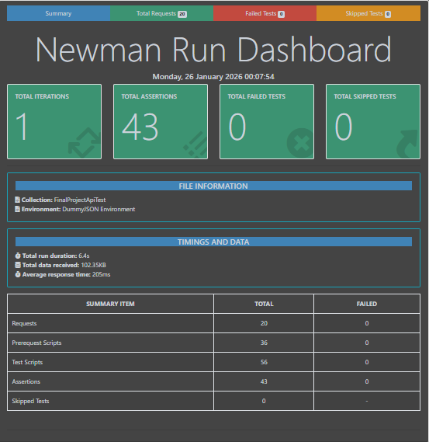

10.2 Newman Execution Based on CSV Data
The following screenshot shows the Newman execution based on CSV input data for multiple users:
- Screenshot 3: 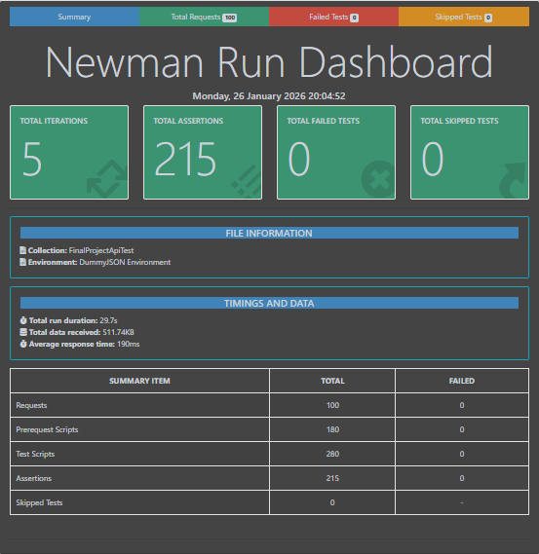

10.3 k6 Performance Test Results
The performance testing was conducted using k6 for both Smoke and Load Testing. Below are the respective screenshots from the k6 test results:
- Screenshot 4: k6 Load Test

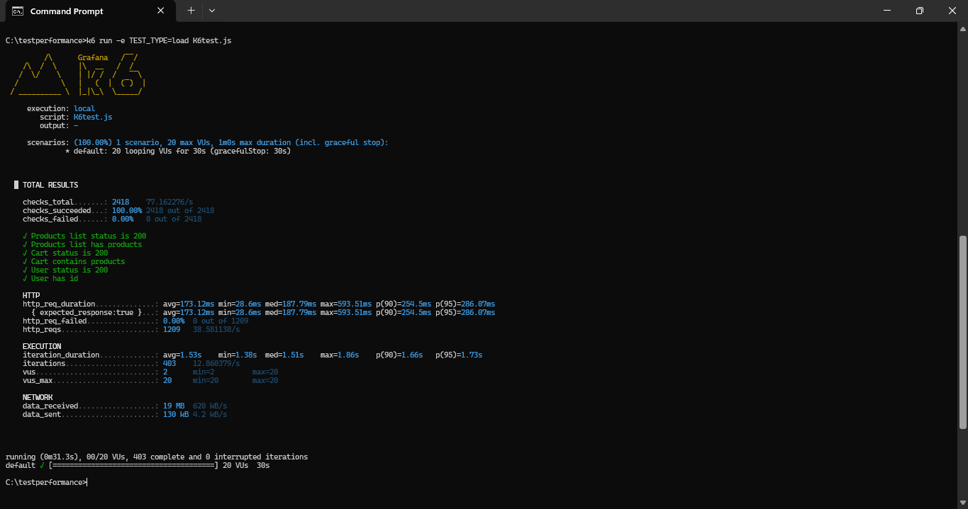

Screenshot 5: k6 Smoke Test

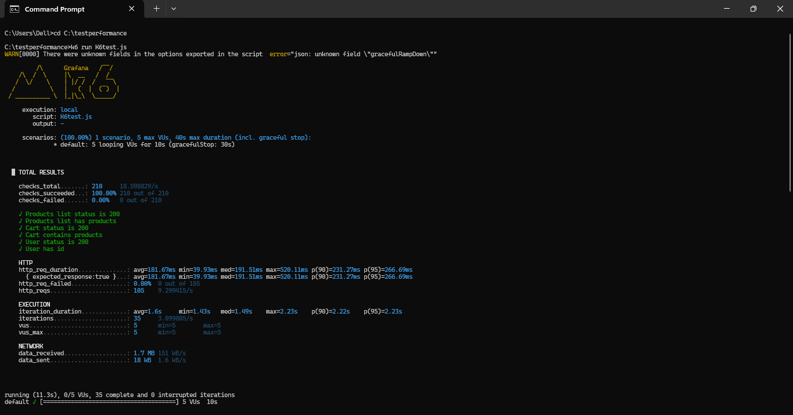

11. Conclusion
11.1 Project Summary
The objective of this Software Testing project was to apply various testing methodologies and tools to evaluate the functionality, performance, and reliability of the Loyalty+ Store web application. This report has documented the entire testing process, from planning and strategy to execution and analysis of results.
Key activities performed in this project include:
- Manual Testing of core user functionalities such as login, product interactions, cart management, and checkout.
- API Testing using Postman and Newman, ensuring that all endpoints return the expected responses and function under varying conditions.
- Performance Testing using k6, evaluating the system’s ability to handle load and stress under realistic traffic scenarios.
- UI Automation using Selenium, validating key user journeys and ensuring that the system behaves as expected.

11.2 Key Findings
Based on the testing activities, the following key findings were made:
- Functional Correctness: The system passed the majority of the manual and automated tests, confirming the reliability of core functionalities like login, adding/removing items from the cart, and completing the checkout process.
- API Performance: The API performed well under both smoke and load test scenarios, with 100% success rate and optimal response times.
- UI Automation: All automated UI tests passed successfully, confirming that the user interface functions as expected across key user journeys.
- Performance and Scalability: The system was able to handle a reasonable load of virtual users during the k6 tests, with no major performance degradation. However, additional tests with higher traffic loads are recommended for long-term scalability.

11.3 Conclusion and Recommendations
The testing efforts successfully validated the functionality, performance, and scalability of the Loyalty+ Store web application. While the system is stable and performs well under typical usage conditions, the following recommendations are made for further improvement:
- Enhanced Load Testing: Conduct more extensive performance testing with higher virtual user counts to better simulate real-world usage and uncover potential bottlenecks.
- Security Testing: As security testing was excluded from this project, it is highly recommended to include vulnerability scanning and penetration testing in future testing phases to ensure the system is secure.
- Cross-Device Testing: Extend the UI automation to mobile platforms to ensure cross-device compatibility, considering the growing use of mobile devices for e-commerce.
In conclusion, the Loyalty+ Store is a robust application with solid functional and performance capabilities. With a few additional tests and enhancements, it can be ready for deployment in real-world environments.
12. References
The following tools and resources were used during the execution of this Software Testing project:
- Microsoft Word: Used for preparing the Test Plan, Test Reports, and documentation.
- Postman: Used for API testing and creating Postman Collections for validating API endpoints.
- Eclipse: Integrated Development Environment (IDE) used for writing and running Selenium WebDriver scripts.
- Selenium WebDriver: Used for automating UI tests on the SauceDemo web application.
- k6: A performance testing tool used for conducting Load and Smoke tests on the API endpoints.
- Newman: Command-line tool used to execute Postman Collections, generating results and reports.
- GitHub: Used for version control, storing and managing the test scripts, reports, and other documentation.
- Microsoft Excel: Used for organizing test data and tracking the results of manual and automated test cases.
Web Resources
- Sauce Labs: The web application SauceDemo (https://www.saucedemo.com) was used for UI automation testing.
- DummyJSON API: The API used for testing was DummyJSON (https://dummyjson.com), a RESTful API for testing CRUD operations.

